Name:Jeevan S U

**Name: Jeevan S U**

**Roll No: 241059038**

**Subject: Cryptology Lab**

**Program: M.E in Cyber Security, MSIS, MAHE**

1. Assume you intercepted the following ciphertext. Using a statistical attack, find the plaintext "XLILSYWIMWRSAJSVWEPIJSVJSYVQMPPMSRHSPPEVWMXMWASVX-LQSVILYVVCFIJSVIXLIWIPPIVVIGIMZIWQSVISJJIVW"

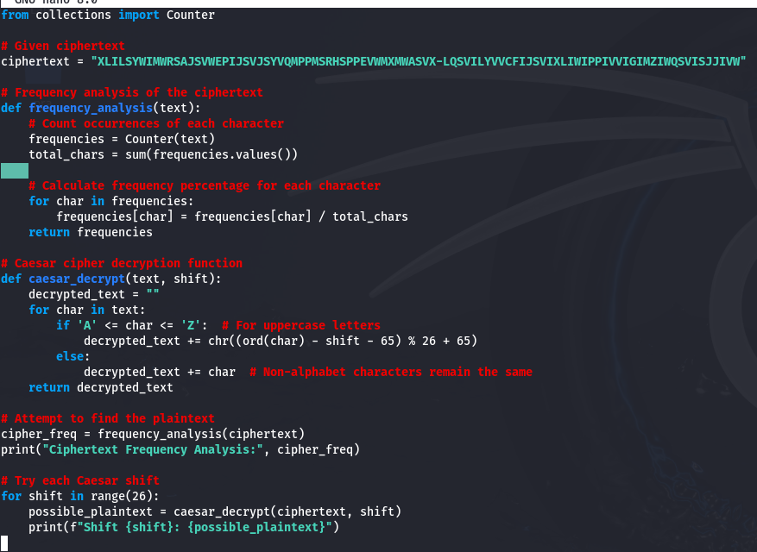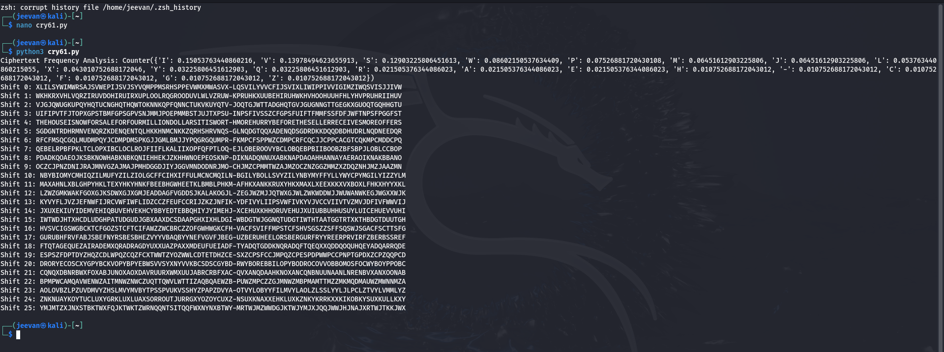

1. Write a Python script to encrypt using Rail Fence (Zig zag ) with three rows and with key (ONE).

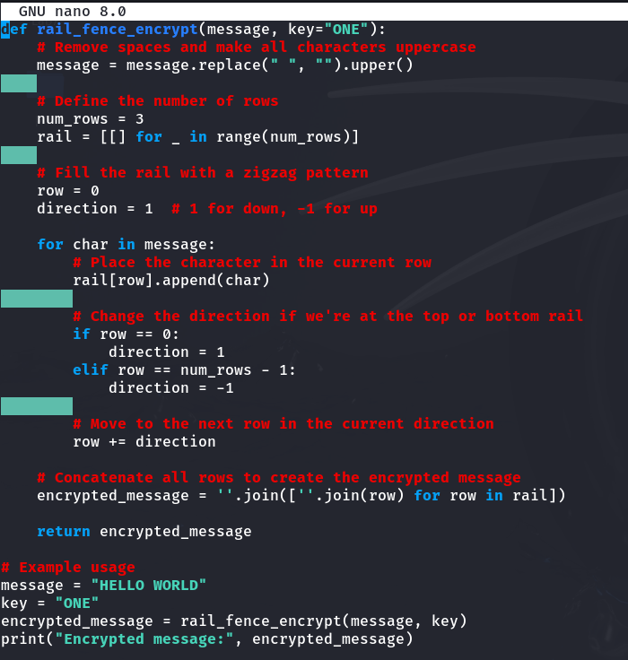

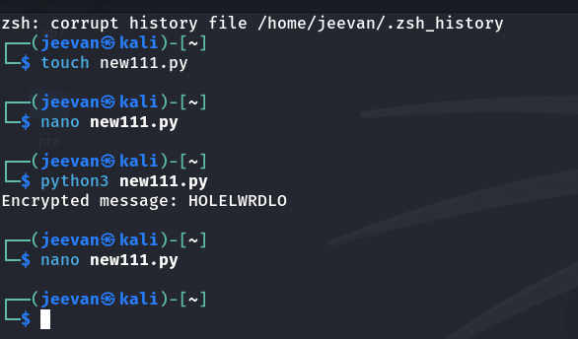

1. Write a python script to encrypt columnar transposition

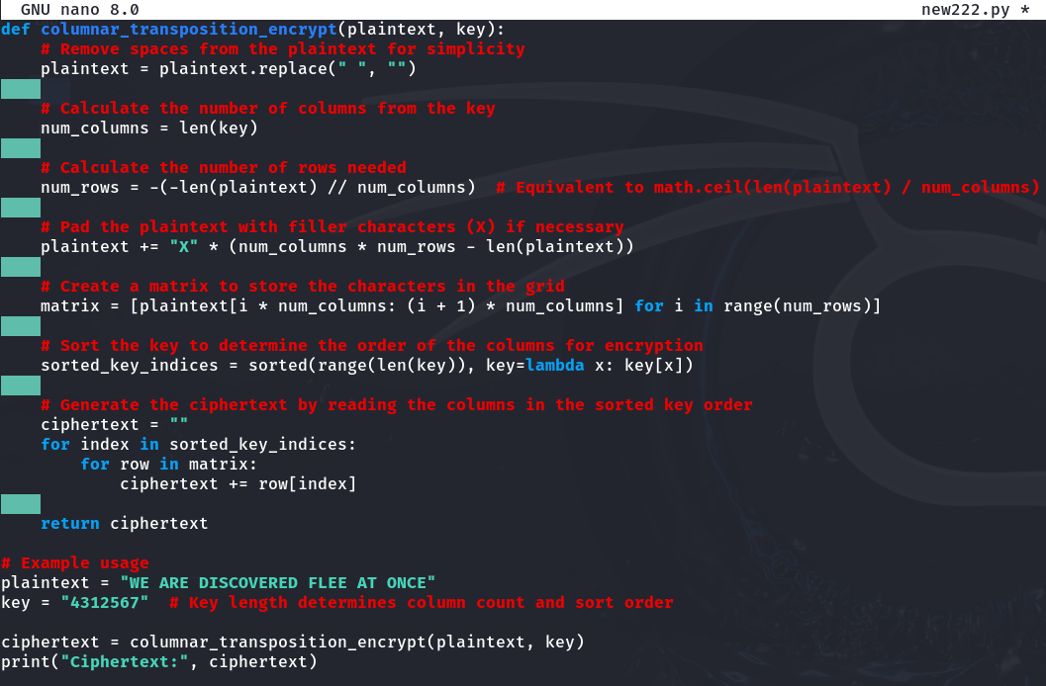

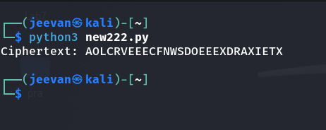

1. Write a Python script to decrypt Rail Fence Cipher.

